Experiment No. 4

**Quadrature Phase-Shift Keying (QPSK) Modulation and Demodulation**

Object:

* To study and understand the principle of Quadrature Phase-Shift Keying modulation and demodulation
* To learn how to implement QPSK modulation and demodulation using Matlab-Simulink.
* To evaluate the performance of QPSK modulation and demodulation over AWAG channel.

Theory:

Digital modulation is a process that impresses a digital symbol onto a signal suitable for transmission over a wired or wireless medium in order to receive that signal at receiving end correctly without any loss of information.

The Quadrature Phase Shift Keying QPSK is one of the most popular digital modulation techniques used for **satellite communications** and sending data over **cable networks**, **videoconferencing**, **cellular phone systems**, and other forms of digital communication over Radio Frequency (RF) carrier.

The Quadrature Phase Shift Keying (QPSK) is one of the most used Phase Shift Keying digital modulations, due to its simplicity, excellent power and bandwidth efficiency. QPSK allows the signal to carry twice as much information as ordinary PSK ‘or BPSK’ using the same bandwidth.

Since phase shift keying offers simple way of increasing the number of levels in the transmission without increasing the bandwidth by introducing smaller phase shift, it is also possible to have a phase shift ¢ ~ 90' which is called Quadrature phase shift keying which (QPSK) has four phases. M-ray has M phases and is denoted by MPSK. For a given bit rate, QPSK requires half the bandwidth of PSK and is widely used for this reason.

QPSK can be generated from two orthogonal BPSK modulated signals (**In-phase component** and **Quadrature phase component**). Therefore, the model of QPSK modulator and demodulator has two branches, the upper branch presents the In-phase component and the lower branch presents Quadrature-phase component.

In QPSK, the data bits to be modulated are grouped into symbols, each containing two bits, and each symbol can take on one of four possible values: 00, 01, 10, or 11. During each symbol interval, the modulator shifts the carrier to one of four possible phases corresponding to the four possible values of the input symbol. In the ideal case, the phases are each 90 degrees apart, and these phases are usually selected such that the signal constellation matches the configuration shown in Figure 1.

Figure 1 Common QPSK constellation

Practical QPSK modulators are often implemented using structures similar to the one shown in Figure 2. This structure uses the trigonometric identity

$I cosω_{c}t+Qsinω_{c}t=R cos⁡(ω_{c}t+θ)$ (1)

Where

$R=\sqrt{I^{2}+Q^{2}} , θ=\tan^{-1}\left(\frac{Q}{I}\right)$

When *I* and *Q* take on values of $±A/\sqrt{2}$ in all possible combinations, the phase of the resulting output signal takes on values of 45, 135, 225, and 315 degrees. If the output of this modulator is to be represented in complex-envelope form referenced to the carrier frequency, the modulated signal is given simply as

$\tilde{x}\left(t\right)=I\left(t\right)+j Q(t)$ (2)

Simulation of this idealized signal requires only a trivial model of the modulator. The complex signal $\tilde{x}\left(t\right)$ is formed by simply using the inphase baseband signal *I(t)* as the real part and the quadrature baseband signal *Q(t)* as the imaginary part.



**Figure 2** Block diagram of QPSK modulator.

**QPSK Modulation**

In digital communication, the modulating wave consists of binary (2-level) or an M-array (M-level) encoded version of data. An M-array PSK modulated signal can be expressed as:

$X_{PSK}\left(t\right)=A\cos\left(ω_{c}t+2πi/M\right) i=1,2……M$ (1)

Where the amplitude *A* is arbitrary constant, *ωc* is the angular frequencies and *θi* the phase has M possible values.

If the system uses a Quadrature Phase Shift Keying (QPSK) which also called **4-PSK modulation**, M=4, the QPSK modulated signals as shown in Figure 3 can be generated as:

$$s_{0}=A\cos\left(ω_{c}t+\frac{π}{2}\right)=-A sin⁡(ω_{c}t)$$

$$s_{1}=A\cos\left(ω_{c}t+π\right)=-A cos⁡(ω_{c}t)$$

$$s_{2}=A\cos\left(ω_{c}t+\frac{3π}{2}\right)=A sin⁡(ω_{c}t)$$

$$s_{3}=A\cos\left(ω_{c}t+2π\right)=A cos⁡(ω_{c}t)$$

The outputs of In-phase and Quadrature-phase branches of QPSK modulator are:

$S_{i}\left(t\right)=I\left(t\right)A cos\left(ω_{c}t\right)=±A cos\left(ω_{c}t\right), S_{Q}(t)=Q(t)A sin(ω_{c}t)=±A sin(ω_{c}t)$ (2)

The final output of QPSK modulator is:

$QPSK=A \left[I\left(t\right) cos\left(ω_{c}t\right)+Q(t)\sin\left(ω_{c}t\right)\right]$ (3)

To show QPSK on the constellation diagram, outputs of In-phase and Quadrature-phase branches of QPSK modulator are considered as Real and imaginary components as shown:

$QPSK=∓A \left[\cos\left(ω_{c}t\right)±j\sin\left(ω_{c}t\right)\right]$

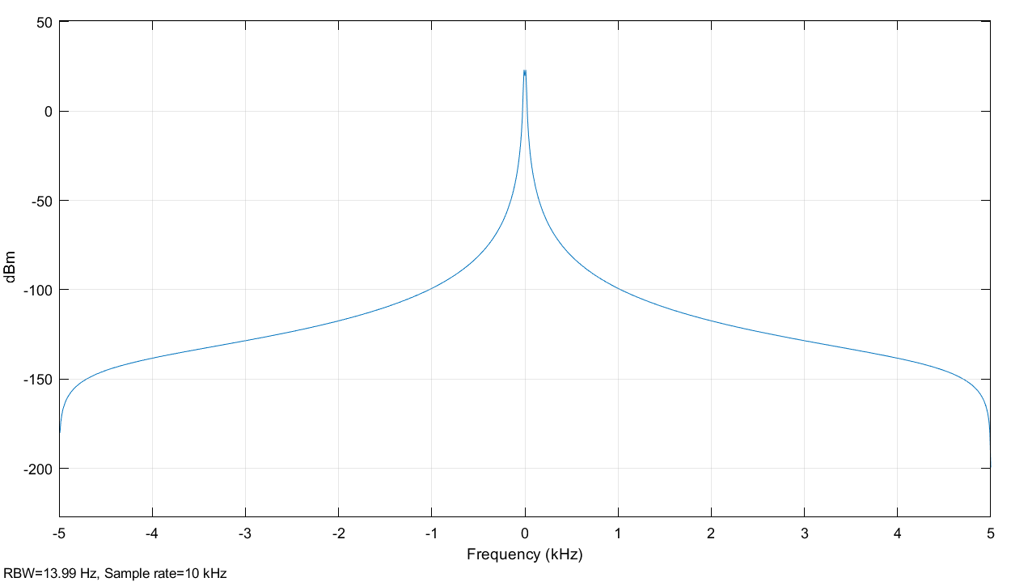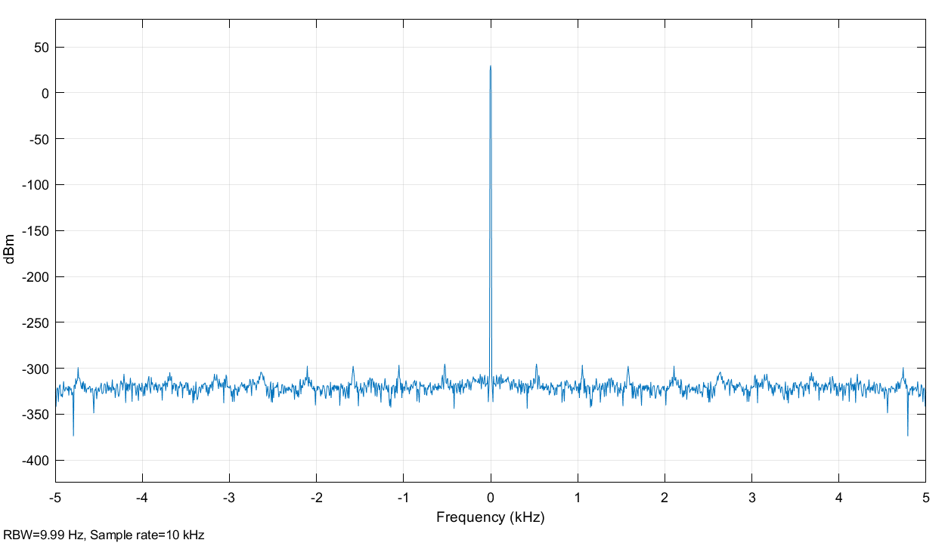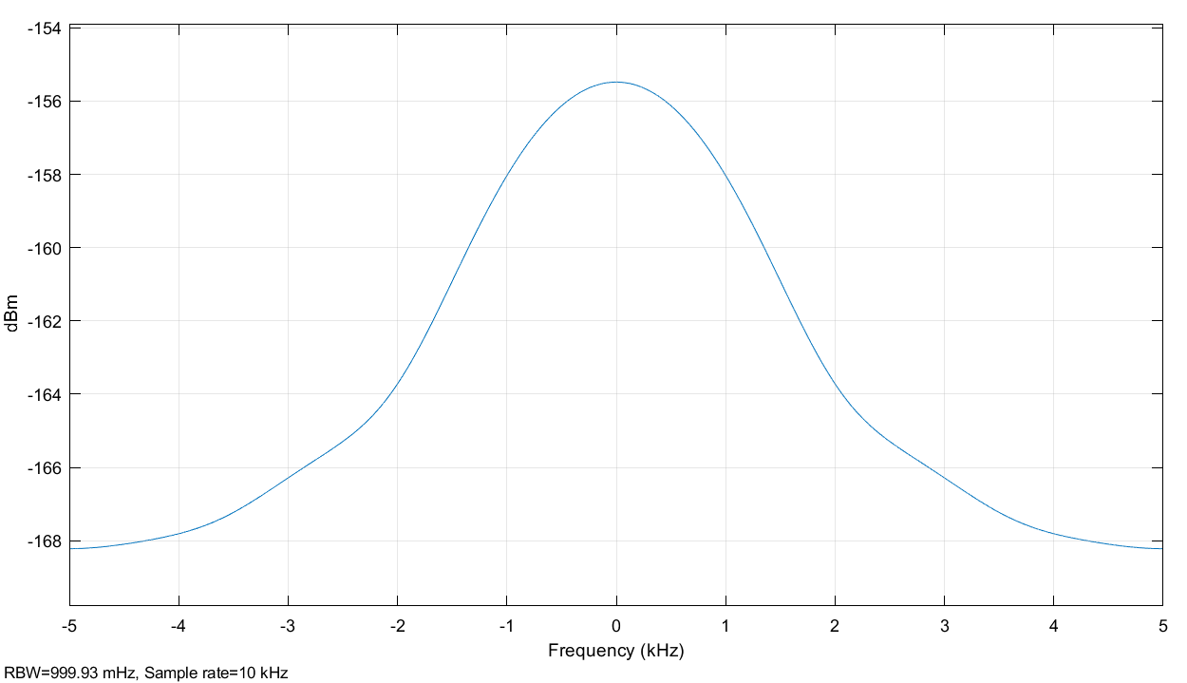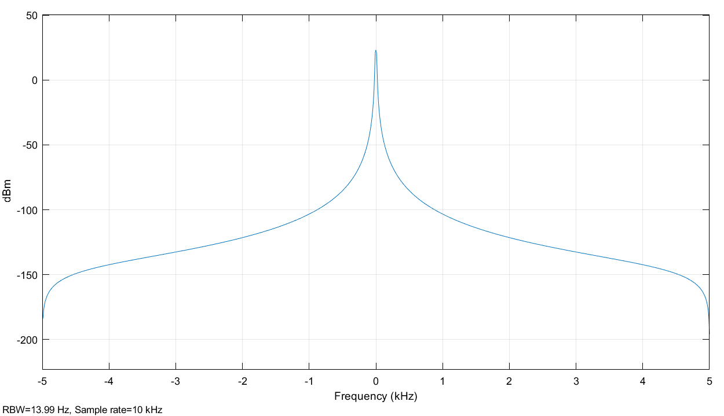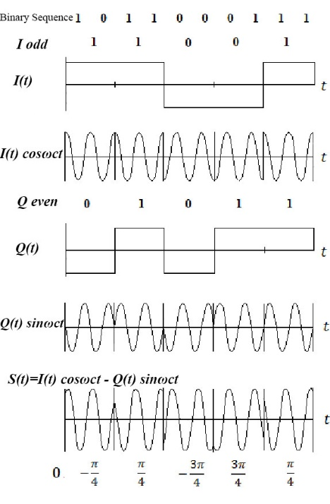

I(t) or Q(t)

Binary Sequence

I(t)cosωct or Q(t) sinωct

S(t)= I(t)cosωct -Q(t) sinωct

Figure 3 QPSK modulation waveforms and their frequency domains

**QPSK Demodulation**

The method of demodulation is an important factor in determining the selection of a modulation scheme. There are two types of demodulation which are distinguished by the need to provide knowledge of the phase of the carrier: Correlation Demodulator and Coherent (Synchronous) Demodulator. In this experiment, we concentrated on the second one**.**

QPSK provides a very acceptable performance level with a near minimum RF bandwidth. The processing of QPSK is more complicated than PSK because two separate demodulators are required. The demodulator complexity increases rapidly for M-ray PSK and for this reason it is rarely used.

This demodulation scheme needs to realize the carrier phase. Coherent demodulation requires more complex circuitry, Coherent demodulation System multiplies the QPSK signal by the two locally regenerated (replica) carriers (cosine and sine) with keeping on realization of the phase of the replica carrier signal, termed local oscillator, ‘locked’ to the carrier. The operation of keeping the phase of the replica carrier is difficult to be achieved. In general, Oscillators are sensitive to temperature, noise, and will gradually drift in frequency and phase. There are two methods to prevent such an occurrence in one, a pilot carrier signal is sent together with the modulated carrier. This pilot carrier is used to synchronize the local oscillator phase. Figure 4 shows a block diagram of coherent QPSK demodulator and each stage’s output waveforms. To explain the operation of coherent QPSK demodulation, we express the operation through equation as follows:

we consider the input signal is QPSK(t)=I(t) $\cos\left(2πf_{c}t\right)-Q\left(t\right)sin\left(2πf_{c}t\right)$, the local generated carriers c1(t)= cos(*2πfct)* andc2(t)= -sin(*2πfct)*.

$$\tilde{I}\left(t\right)=QPSK\left(t\right)*c_{1}\left(t\right)=[I\left(t\right)\cos\left(2πf_{c}t\right)-Q\left(t\right)sin\left(2πf_{c}t\right)]*\cos\left(2πf_{c}t\right)$$

$$\tilde{Q}\left(t\right)=QPSK\left(t\right)*c_{2}\left(t\right)=[I\left(t\right)\cos\left(2πf_{c}t\right)-Q\left(t\right)sin\left(2πf_{c}t\right)]*-sin\left(2πf_{c}t\right)$$

$$\tilde{I}\left(t\right)=I\left(t\right)\cos^{2}\left(2πf_{c}t\right)-Q\left(t\right)sin\left(2πf_{c}t\right)\cos\left(2πf_{c}t\right)$$

$$=\frac{I\left(t\right)}{2}(1+cos\left(4πf_{c}t\right))-\frac{Q\left(t\right)}{2}sin\left(4πf_{c}t\right)$$

$$\tilde{Q}\left(t\right)=-I\left(t\right)\cos\left(2πf_{c}t\right)\sin\left(2πf_{c}t\right)+Q\left(t\right)\sin^{2}\left(2πf_{c}t\right)$$

$$=-\frac{I\left(t\right)}{2}\sin\left(4πf_{c}t\right)+\frac{Q\left(t\right)}{2} (1-cos⁡(4πf_{c}t)$$

After low pass filter with the cutoff frequency *fc*,

The main characteristics of QPSK are:

* Sometimes this is known as quadriphase PSK, 4-PSK, or 4-QAM. (Although the root concepts of QPSK and 4-QAM are different, the resulting modulated radio waves are exactly the same.)
* QPSK uses four points on the constellation diagram, equispaced around a circle.
* With four phases, QPSK can encode two bits per symbol, shown in the diagram with Gray coding to minimize the bit error rate (BER) – sometimes misperceived as twice the BER of BPSK.
* The mathematical analysis shows that QPSK can be used either to double the data rate compared with a BPSK system while maintaining the same bandwidth of the signal, or to maintain the data-rate of BPSK but halving the bandwidth needed.
  + The BER of QPSK is exactly the same as the BER of BPSK
  + QPSK transmits twice the data rate in a given bandwidth compared to BPSK - at the same BER.
  + The engineering penalty that is paid is that QPSK transmitters and receivers are more complicated than the ones for BPSK. However, with modern electronics technology, the penalty in cost is very moderate.
  + As with BPSK, there are phase ambiguity problems at the receiving end, and differentially encoded QPSK is often used in practice.

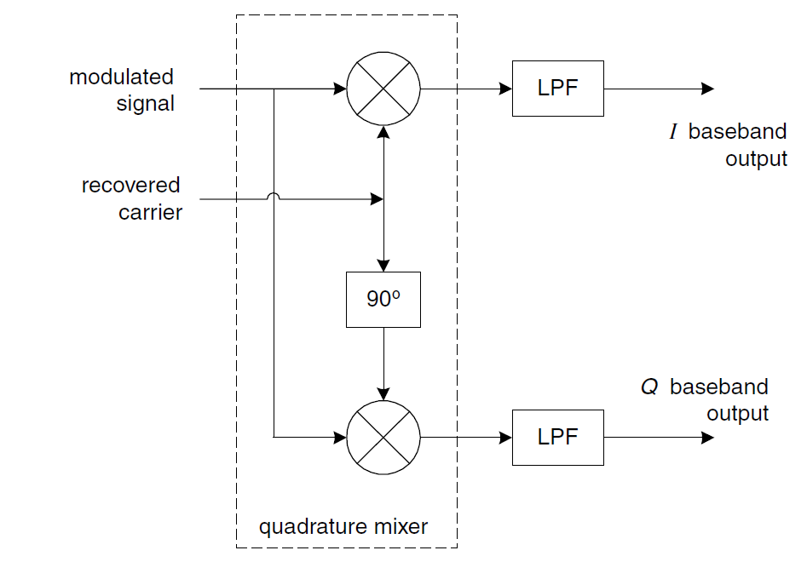

Figure 3 Coherent QPSK Demodulator

**Procedure**

**Part A: Simple QPSK Modulator and Coherent Demodulator**

1. Implement the QPSK modulator and demodulator shown in Figure 4.
2. To encode the message *m(t)to* generate NRZ, we use Bernoulli Binary generator and to convert RZ to NRZ, we shift the binary to negative axis by -0.5 and then to bipolar binary sequence using Sign Function.
3. Set the parameters of the sine generators for each branch as follow:

For **In-phase branch (cos(*2πfct*)):**

**Amplitude**: 1V, **Frequency (rad/sec):** 4*2*π, **Phase: $\frac{π}{2}$** , **Sample time:** 0.001

For **Quadrature-phase branch (-sin(*2πfct*)):**

**Amplitude**: -1V, **Frequency (rad/sec):** 4*2*π, **Phase:**0, **Sample time:** 0.001.

1. Set the parameters of the Analog Filter Design as follows:

**Design method**: Butterworth, **Filter type**: Lowpass, **Filter order**: 8, **Passband edge frequency(rad/sec):** 4*2* π.

1. Set the parameters of Switch functions with the **threshold** 0.0001 and the **criteria** u2>threshold.
2. Plot the signals in each scope.
3. What happened when you changed the cutoff (**Passband edge) frequency** to 10*2*π?



Figure 4 Simple QPSK Modulator and Coherent Demodulator

**Part B: Realistic QPSK modulator and Coherent demodulator**

1. Implement the Realistic QPSK modulator and Coherent demodulator shown in Figure 5.

1. Repeat the setting of the parameters of the components as shown in Part A.
2. Set the parameters of Analog Filter Design (Mod) as follows:

**Design method**: Butterworth, **Filter type**: Bandpass, **Filter order**: 8, **Lower Passband edge frequency(rad/sec):** 0.16, **Higher Passband edge frequency (rad/sec):** **127**

Notice: 1 **Radian** per **second** is comparative to 1/2π **Hertz**

1. Set the parameters of AWAG channel as follows:

**Input processing**: Columns as channels, **Initial seed**: 67 (or any number)

**Mode**: Signal to noise ratio (SNR), **SNR (dB)**:30, **Input signal power (watts)**:1

1. Set the parameters of Rate Transition with **Initial condition** 0 and Output port sample time 0.0001.
2. In Spectrum Analyzer, Change the RBW (Hz) in Spectrum settings by 10, the dialogue box is found in View.

Figure 5 Realistic QPSK Modulator and Coherent Demodulator

1. In Eye diagram properties dialogue boxes, set the parameters of eye diagrams where **samples per symbol** by 625 and samples per trace by 2
2. Plot the signals in each scope and record the error rate.
3. What will happen when you change **SNR (dB)** of the AWAG channel to 10 or change the cutoff frequency of lowpass filter to 10*2*π?

**Discussion**

1. From the results, explain the effect of AWAG channel or the effect of cutoff frequency of lowpass filter on QPSK signal.
2. What are the maximum rate and bandwidth of QPSK modulation?
3. The BER of QPSK is exactly the same as the BER of BPSK, Explain Why the QPSK is better than BPSK.
4. Explain the QPSK modulation challenges and problems.
5. Explain through equations what happen if there is a phase error *θc* between the transmitted QPSK signal and local (replica) carrier signals in coherent QPSK demodulator. Then what happen if *θc*=90o.
6. Name of Filter type that is missed in our QPSK system in this experiment and why it is importance.
7. QPSK can be generated from two orthogonal BPSK modulated signals, Define them.